July 30, 2026

Dear Parent:

Your child has been selected to receive this special packet from the school nurse because he/she has asthma. This packet contains information about asthma, as well as a back-to-school asthma checklist, an Asthma Action Plan, and a Ziploc bag for you to put your child’s medication/spacer in to return to the school nurse. Please complete all of the items on the checklist, return the packet to the school nurse with the completed Asthma Action Plan and properly labeled medication/spacer, and your child will receive a prize from the school nurse. Thank you for your assistance.

“Working together we can help our children breathe better”
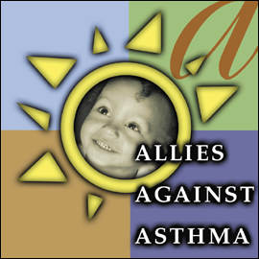

This packet was created through a partnership between
local school nurse coordinators and Allies Against Asthma.

Allies Against Asthma is a work group of the Consortium for Infant and Child Health (CINCH).
CINCH is a program of the Center for Pediatric Research, a joint program of
Children’s Hospital of The King’s Daughters and Eastern Virginia Medical School.
BACK-TO-SCHOOL ASTHMA CHECKLIST

Here’s a list of things to do before your child goes back to school, so that he/she will be prepared if he/she has problems with his/her asthma at school. Your child will receive a prize for returning these things to the school nurse. You will feel better knowing that your child’s asthma is under control.

How to get ready for school:

- Fill in top portion of Asthma Action Plan/Medication Order. Sign and date bottom part where it says parent signature before you go to doctor.

- Make and keep appointment with child’s doctor. Take this form and Asthma Action Plan/Medication Order with you when you go to doctor.

- Have the doctor fill out the rest of the Asthma Action Plan/Medication Order at the appointment.

- Ask your child’s doctor for a prescription for medicine for school.
For example:
1 Albuterol inhaler (puffer) for school

1 Spacer (with mask, if needed) for school
**Most insurance companies will approve 2 sets of spacers and medications per year, but the prescription must say “for school” and must say “medical necessity”**

Take Medicine and Supplies to School:

- Place one spacer and one reliever (Albuterol) inhaler in the Ziploc bag provided in this folder (to stay at school). Label bag with child’s name.

Medications must be in original packaging with pharmacy label.

- Place completed Asthma Action Plan and Ziploc bag with spacer and medication in this plastic folder and give to school nurse.

