
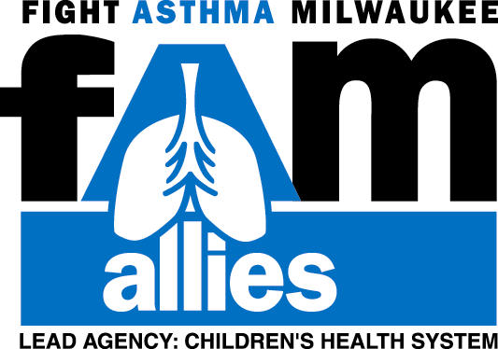

Catch Your Breath – Asthma Survival Skills Evaluation

Topic: Asthma Date:

Please rate the workshops using the following scale:
1=POOR 2=FAIR 3=GOOD 4=VERY GOOD 5=EXCELLENT

1. Content

- Related to caring for children with asthma 1 2 3 4 5

- Useful to me 1 2 3 4 5

2. Goals of the session were met 1 2 3 4 5

3. Helpfulness of presenter (s) 1 2 3 4 5

4. Training: Overall rating 1 2 3 4 5

5. My expectations were met 1 2 3 4 5

Additional Training Questions (please answer completely);
What was best about this training?

What did you learn that will best help you to better care for children with asthma?

How will this program change how you manage asthma?

How can this training be improved?

What suggestions do you have for other workshops? What kinds of information about children with asthma
would you like to see in future workshops?
Revised 8/29/01

